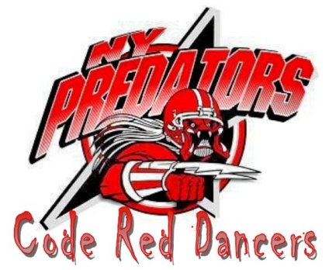
Audition Application
Eligibility:
About the Code Red Dancers: The NY Predators Code Red Dancers were created in 2007 to enhance the overall fan experience by infusing additional energy and enthusiasm to each home game. Members of the multi-talented, multi-purpose entertainment team are dancers, athletes, ambassadors and active participants in the Predators community. Whether they are performing a choreographed dance routine, cheering on the sidelines or appearing at charity events, every member of Code Red is committed to excellence and serving as role models for Predators fans and representatives of the NY Predators organization.
*Must be 18 years of age or older and a high school graduate.
*Must be available to attend all weekly rehearsals, all home games and promotional appearances.
*Must be willing to travel throughout the NY Metro Area.
*Must allow for scheduling flexibility throughout the NY Predators regular and playoff season.

Audition Attire:
*Sports bra/cropped top/fitted tank top* shorts* Skin colored dance tights* Any type of dance shoes* Performance-ready hair and makeup*

AUDITION PROCESS
Preliminary Round: Contestants will perform a freestyle dance showcasing their turning, leaping, jumping, and other technical skills. Music will be provided for this round.
Semi-final Round: Contestants will be taught 2 dance combinations and 2 cheers/chants. Following the teaching portion, contestants will perform the dance combinations and cheers in front of the judges.
Semi-final Round: Final Round and Interviews: Each finalist will perform a 60-90 second solo dance combination in any style of their choosing. This may also include a cheer if the contestant would like. Music must be provided on CD for this portion of auditions. Following solo presentations, contestants will again perform all material learned, including but not limited to dance combinations, cheers and possibly a kickline.
Following dance performances a brief interview will be conducted.
Those chosen for the 2012 Code Red Dancers will be announced at the end of the final round.

Personal Information

Name:____________________________________________________________
Cell Phone: _______________________________________________________
Email Address:_____________________________________________________
Birthdate__________________________________________________________
High School:_______________________________________________________
Graduation Year:____________________________________________________
College:___________________________________________________________
Graduation Year:____________________________________________________
Major:_____________________________________________________________

Performance/training experience:
__________________________________________________________________________________________________________________________________________________________________________________________________________________________________________________________________________________________________________________________________________________________________________________________________________________________________________________________________________________________________________________________________________________________________________________________________________________________________________________________________________________________________________________________________________________________________________________________________________________________________________________________________________________________________________________________________________________________________________________________________________________________________________________________________________________________________________________________________________________________________________________________________________________________________________________________________________________________________________________________________________________________________________________________________________________________________________________________________________________________________________________________________________________________________________________________________________________________________________________________________________________________________________________________________________________________________________________________________________________________________________________________________

